APPLICATION OF DECIMAL TO HEXA CONVERSION:

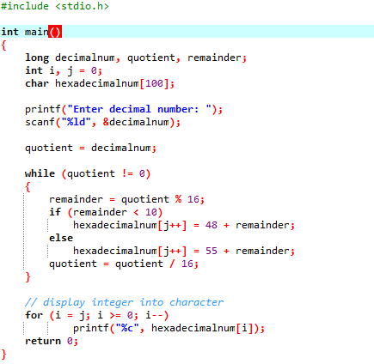

OUTPUT:

